Show Data from database using Ajax.

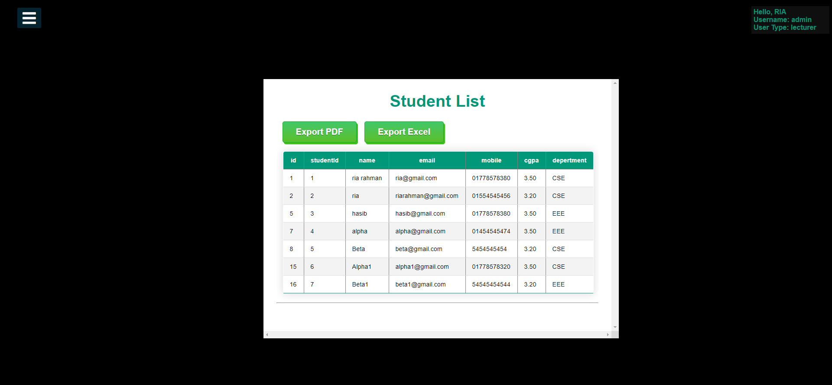

<script>

        $(document).ready(function(){

            displaydata();

            function displaydata(){

                $.ajax({

                    url:'getdata.php',

                    type:'POST',

                    success:function(responsedata){

                        $('#response').html(responsedata);

                    }

                });

            }

        });

    </script>